Final Project Report

Implementation of PSO with NANOBOTS for treating cancer

* Niravra Kar

NU ID – 001252638

# Problem Statement

* Chemotherapy helps in tackling cancer, but it also has an impact on healthy cells
* One of the most researched area is to design tiny robots to carry drugs directly to the cancer cells

# PSO Algorithm Implementation

The PSO algorithm is used with the coefficients w = 0.729844, C1 & C2 = 1.49618

(Shi, 2000)

Update Equation

X(t) is used to denote the iteration of a particle, so the next position is calculated as:

*x(t+1) = x(t) + v(t+1)* (gandhi, 2014)

The Velocity equation is calculated as

*v(t+1) = w*v(t) + c1*r1*(pBest(t) - x(t)) + c2*r2*(gBest(t) - x(t))* (gandhi, 2014)

Key points:

* Swarm size of the bots is taken as 50
* The fitness factor is calculated based on the protein and adhesion amount of the cell
* The position having the highest chance factor is updated as the global best
* All other particle velocities are updated to match the best location, until some other global best is found
* The real-time location of the particles is shown along with the protein and adhesion quantity

# Screenshot

Initial swarm scattered location

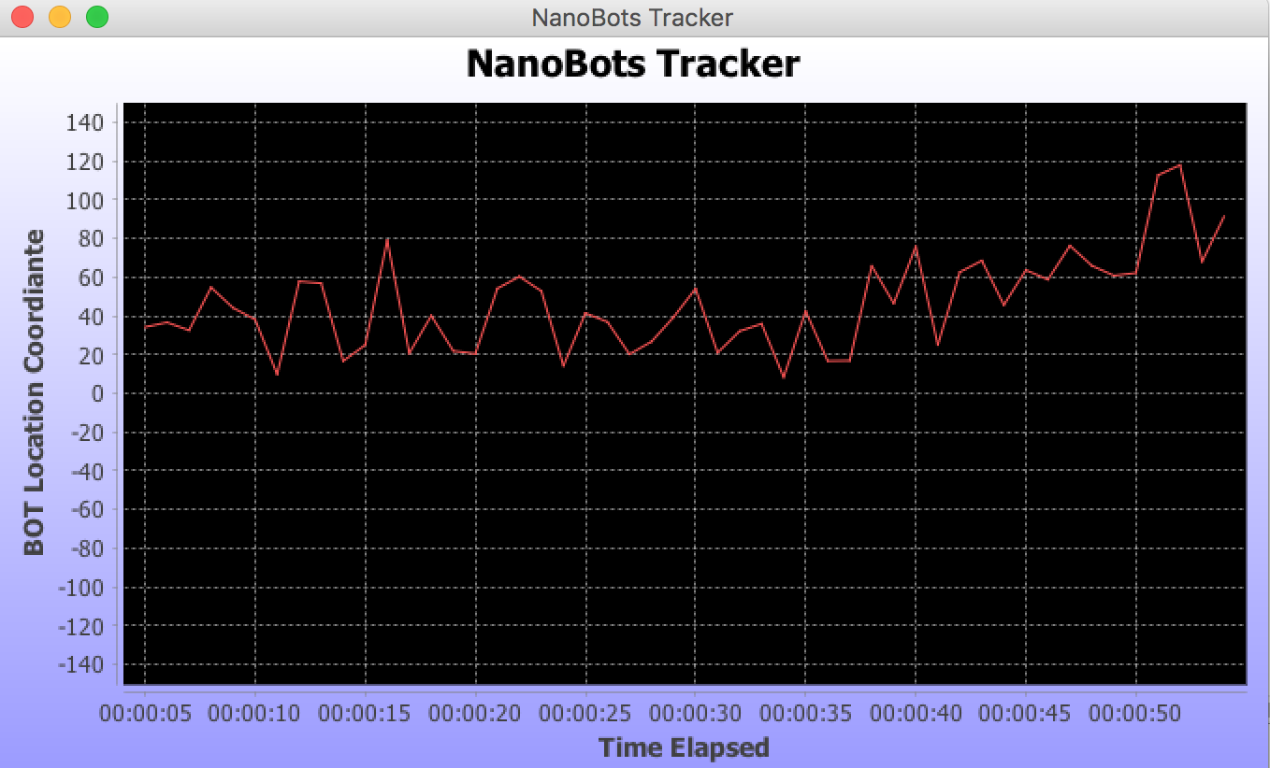

After some time

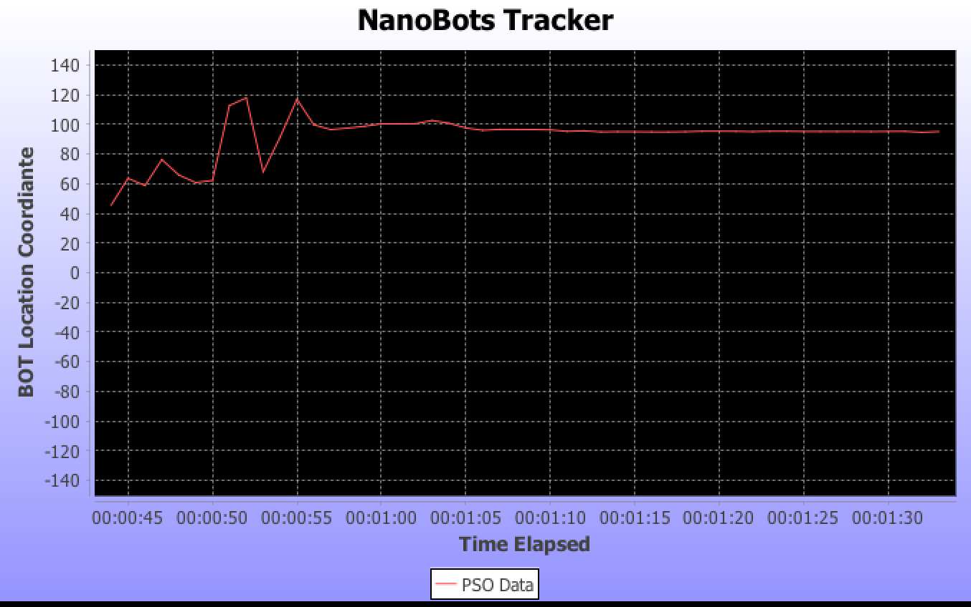

All the nanobots will be converging to the same area after a period, which will solve the actual purpose of Delivering medicine directly where it's needed which not only minimizes side effects but also makes the drugs more effective. (McSweeney, 2016)